horizontal line

**Long Flight Time Buoyant Drone**

12.09.2020

Dylan Arius Harootunian

Chin Ming Ryan Wong

George Hernandez

Jeremy Germenis

Leonid Shuster

Isaac Szu

Table of Contents

**Primary Client and Final Problem Statement** **2**

Project Background 2

Client Information 2

Problem Statement 3

**Scope of Work** **4**

Goals 4

Stretch Goals 4

Simulation Deliverable 4

Small Scale Test Deliverable 5

**Methodology** **6**

Pugh Chart 6

High Level Design 8

Program Level Design 9

Team Composition 10

**Validation and Impact Assessment** **12**

Success Criteria Matrix 12

Impact Assessment 14

**Parts List and Budget** **17**

Parts List 17

Budget 18

**Timeline and Major Milestones** **19**

Flowchart 19

General Timeline 20

Milestones 21

**Annotated Bibliography** **22**

# Primary Client and Final Problem Statement

## Project Background

Aerial drones have been an important part of technological innovation for the past few decades. This is even truer for drones that are small, compact, and able to be remotely controlled. With several of our group members being experienced with drones and how to simulate them, this project was conceived to further that area of expertise. More specifically, this project had the specific idea of implementing a system in which the drone’s lift is sustained through natural air buoyancy.

Drones have opened up new possibilities for data collection and surveying, military applications, and for the hobby world. Small scale drones are usually limited to short flight times since most of the energy a drone expends is to maintain flight, and not to move around. If buoyancy were introduced, the primary energy draw of the drone is reduced, allowing for smaller electronics and a longer flight time.

Multiple clients were reached out to, including NASA AMES, Cal-Fire, and the US Air Force, before deciding on the United States Geological Survey (USGS) as the primary client. Professor Mircea and his graduate student Gordon Keller have also provided guidance on how to approach the project, and they recommended the USGS. We have contacted a representative of the USGS, Jonathan Glen, a Research Geophysicist who works with drones on survey missions.

## Client Information

| Sponsor Name | Title | Organization | Contact Email | Project Role | Frequency of Communication |
| --- | --- | --- | --- | --- | --- |
|  |  |  |  |  |  |
| Jonathan Glen | Research Geophysicist | USGS | jglen@usgs.gov | Client | TBD |
| Mircea Teodorescu | Associate Professor (ECE) | UCSC | mteodore@ucsc.edu | Mentor | As needed |
| Gordon Keller | Grad Student | UCSC | ghkeller@ucsc.edu | Mentor | As needed |
| Gabriel Elkaim | Undergraduate Director (Robotics) | UCSC | elkaim@soe.ucsc.edu | Mentor | As needed |

## Problem Statement

The United States Geological Survey uses drones to map the earth’s magnetic field. The current drone is a hexacopter that, due to its limited flight time, requires seven flights to complete a single set of data collection. Additionally, the motors introduce a source of magnetic interference for the magnetometer. A drone capable of achieving longer flight times while also reducing the magnetic interference from the drone would help the USGS with their work.

# 

# Scope of Work

## Goals

* Design a drone that is able to fly with a 2kg magnetometer for one hour. The drone should be able to fly in mild to moderate wind conditions. For the full scale design, the drone will be designed and simulated.
* A small-scale version will be built and tested as a proof of concept with magnetometer accuracy, flight time, and wind response tests included.
* A detailed technical report including parts and design of the full scale and small scale drone will be provided.
* Software documentation will also be provided that includes all the code as well as descriptions of the functions and how to use the software.

## Stretch Goals

* The drone has potential applications in other areas of data collection, so a modular mount for different sensor payloads will be designed.

## Simulation Deliverable

Due to the Covid-19 pandemic and the additional restrictions involved, a full scale build is not feasible within the academic year. The full scale drone will be designed and simulated with the following goals:

* Implement an autopilot system in order to test autonomous movement for the drone to remain buoyant through self-correction using feedback control.
* Provide individual propellor forces to each rotor, so they are capable of acting independently.
* Simulation should be able to record each parameter of the drone including vehicle speeds, rotations, and inertial position.
* Drone stays within 4 meters of the assigned path during movement.
* Simulations of wind disturbances account for a varying level of strength and wind types.
* Movement within the drone simulation is as close as possible to the actual environment.
* A terrain will be simulated and the drone’s response will be tested in its maneuverability to compensate for it.

## Small Scale Test Deliverable

For the proof of concept, a smaller scale version of the drone will be designed, fabricated, and tested. Professor Mircea Teodorescu offered us space in the drone lab at 2300 Delaware St, Santa Cruz, as well as access to manufacturing equipment. The lab is designed for indoor flight testing for small aircraft and is perfect for our needs. Since the full scale drone will be quite large to carry the 2kg payload, we plan to build and test a small scale version around a tenth of the full size in the lab. This drone would be able to lift a 200g payload. This will be the final step in this project.

# 

# Methodology

## Pugh Chart

In general, as the buoyancy of the drone increases, the motor usage decreases, resulting in an increase in flight time and a decrease in magnetometer interference caused by the motors. Terrain tracking would not greatly change as buoyancy changes. Since higher buoyancy designs will be larger, the wind will have a greater effect on the drone, reducing its stability. Finally, with an increase in helium usage for extra buoyancy, the cost would increase as well.

Data collection is the main priority of the drone, so flight time and magnetometer accuracy were given a weight of three. Terrain tracking and stability in wind are also important to achieve accurate results, but less important than the previous two factors, so they have a weight of two. Cost and helium use are also factors, but are less important. The budget was set with a max of $10,000, so as long as the cost is below that ceiling, it is less of a priority. Since helium is a valuable resource, its usage is considered, but the quantity used by a single drone is low, so ‘helium use’ is weighed lightly.

| Design/Feature | Flight Time | Magnetometer Accuracy | Terrain Tracking | Stability in Wind | Cost | Helium Use | Total | Notes |
| --- | --- | --- | --- | --- | --- | --- | --- | --- |
|
| Weighting: | 3x | 3x | 2x | 2x | 1x | 1x |  |  |
|
| DJI Matrice  600 Pro (for reference) | 0 | 0 | 0 | 0 | 0 | 0 | 0 | Current Drone |
|
| H-Aero Drone | +++++ | +++ | 0 | --- | -------- | --- | 7+ | Available Buoyant Drone |
|
| Slightly Buoyant | + | + | ++ | - | ++ | - | 9+ | Small Scale Test |
|
| Moderately Buoyant | ++ | ++ | ++ | -- | ++ | -- | 12+ | More Realistic Target |
|
| Almost Neutrally Buoyant | +++ | +++ | ++ | --- | + | --- | 14+ | Ideal Target |
|
| Neutrally Buoyant | ++++ | ++++ | + | ----- | + | ---- | 13+ | Potential Control Issues With Altitude |
|

The DJI Matrice Pro is the current drone the USGS uses, so that model is used as a baseline and all the values are zero. For a data run, the drone makes seven fifteen-minute flights. It costs $6,000. Another issue the drone has is that it struggles with terrain following so that is an area that could use improvement.

The H-Aero drone is a buoyant drone that is currently on the market. The flight time is 400 minutes, so this is by far the longest flying drone. Also, since the electronics are smaller, there would be less interference with a magnetometer. Due to the drone’s slow response time, it doesn't improve on terrain tracking. It is also $30,000, well over the max budget of $10,000.

A slightly buoyant drone increases flight time and magnetometer accuracy. The costs would be fairly low compared to other buoyant designs, and the response to wind will also be improved due to being compact. Helium use remains low and terrain tracking will have the same package as our other designs and adjustment capability. There is little advantage to this drone design over standard drones.

A moderately buoyant design increases flight time and magnetometer accuracy even more than the slightly buoyant design, but will have decreased ability to handle winds and will use more helium. Since the magnetometer is fairly large and weighs 2kg, the size of the lift bag may put us in the range of this design.

An almost neutrally buoyant drone would provide the least interference and longest flight time, but also would greatly suffer from the wind and increased helium use. An almost neutrally buoyant drone would be the ideal solution, but the size of the lift bag may make this design infeasible.

The neutrally buoyant drone would be similar to the almost neutrally buoyant drone; however, a neutrally buoyant drone would have an additional problem that will arise in terrain tracking: the drone would have to push both up and down, and controlling brushless motors across the 0 rpm range is very difficult, and not worth a small improvement in flight or data accuracy. This design suffers the most from heavier wind speeds and would be harder to implement, offering no significant advantage over the almost neutrally buoyant drone.

Based on the Pugh chart, the almost neutrally buoyant design is the most ideal solution, as it balances the increased flight time and decreased magnetometer interference with the increased helium usage and decreased wind stability. If the design proves to be too large, we may move the design into the moderately buoyant range.

## High Level Design

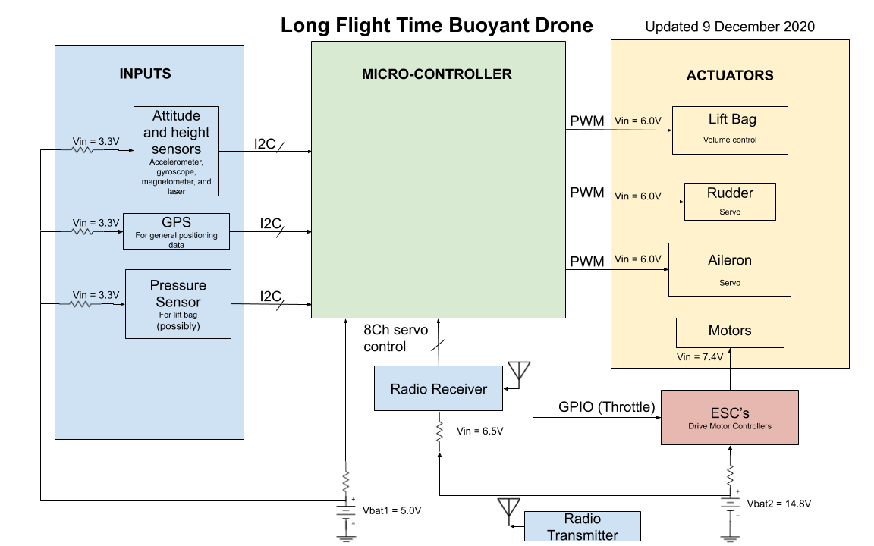

**Added magnetometer to attitude sensors and changed “attitude sensors“ to “attitude and height sensors.” Also changed spelling and spacing 12/9/2020

**Changed “PWM (servo position)” label to “PWM”. Added Height Sensor 12/9/2020

**Removed Propellers block diagram from Actuators. Removed Payload block diagram and Motor Telemetry block diagram from Inputs 12/8/2020

**Removed corner annotation and formatted size of block diagram 12/8/20

**Removed Team Composition from block diagram 12/8/20

**Edited voltage outputs/inputs, add more as we finish it 12/4/20

**Removed internal state machine flow from block diagram 11/25/20

* **INPUTS:** The inputs are a collection of sensors that will be fed into the microcontroller for control. The onboard accelerometer, gyroscope, magnetometer, and GPS will all be used to help determine the attitude and position of the drone. A laser is also used to help with terrain tracking by calculating the drone’s height above ground. Depending on the design, a pressure sensor will also be used on the lift bag to help calculate the responses the control system needs to make.
* **LIFT BAG:** The lift bag provides lift to reduce the net downward force on the drone. The aileron and rudder will be controlled with servo motors and steer the drone. The drone will be driven with propellers powered by BLDC motors.
* **MICROCONTROLLER:** The microcontroller will take input values to determine the current drone state, and output actuator values to fly the drone.
* **RESISTOR:** Resistors are used to step down the voltage inputs to sensors so less batteries can be used.
* **MAGNETOMETER**: The payload magnetometer is not included in the system block diagram, since it works independently of the rest of the system.

## Program Level Design

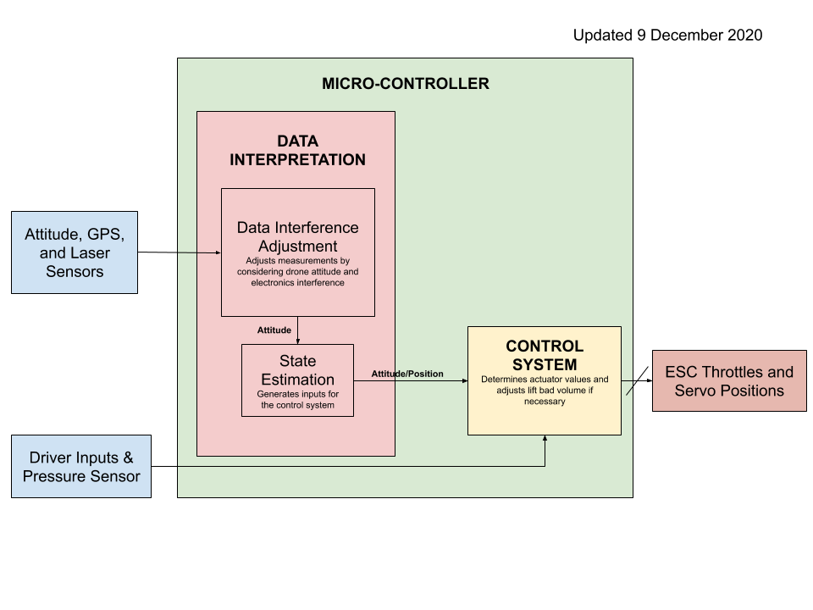

**Removed all magnetometer related blocks, and changed flow of attitude 12/9/20

**Edited outputs to ESC throttle and servo positions 12/9/2020

**Added Sensor blocks to Program design 12/5/20

* **DATA INTERFERENCE:** The sensors will most likely have some noise and biases, so the data needs to be filtered and corrected before being used to calculate the state of the drone.
* **STATE ESTIMATION:** The state estimation uses the information from the input sensors and previous position and attitude to determine the current position and attitude of the drone.
* **CONTROL SYSTEM:** The control system will take in the current attitude and position and output position of the servos and throttles of the motors to get into the next desired position and attitude. If the lift bag pressure is taken, it will also be used to calculate the motor response. This will be closed loop control.

## Team Composition

Dylan Arius Harootunian - Mechanical Design Lead

Robotics engineering student, with a high interest in unique and innovative design. Will primarily be focused on the high level mechanical design of the drone. He is currently taking Intro to Small Scale UAVs where he is learning about the designs of a variety of aircraft. With a healthy amount of CAD experience using Solidworks in Slugbotics, he hopes to refine his skills in design. He also hopes to expand his knowledge in all areas of this project, building off his experience in other engineering related classes, in order to assure that all parts of this project are compatible.

Chin Ming Ryan Wong - PCB Design Lead

Senior undergraduate in electrical engineering. Conducted research, design and prototyping of Arduino Nixie Tube calendar clock. Experienced in Eagle CAD and exporting designs to third party PCB manufacturing. Parts sourcing and C programming for hardware compatibility (I2C/SPI) to arduino SoC. Took classes in CSE100 Computer Logic & Design, ECE102 Properties of Materials, and ECE171 Analog Electronics.

George Hernandez - Control Systems Lead

Electrical engineering major with interest in the control systems field. He is currently taking Intro to Small Scale UAVs where he is developing his control design skills. During the winter quarter he will be taking Introduction to Feedback Control as well as Energy Conversion and Control to increase his experience and bring it to the control system design. Also, he has a background in mechanical design, manufacturing, and electrical systems, so he can assist in other areas.

Jeremy Germenis - Power Management Lead

Electrical engineering major with a focus in electronics. This team member will be focused on making sure the battery is able to handle the power load of all the components involved, as well as making sure that the power drain is able to sustain power for the drone’s maximum flight time. Experience in ECE101, Electronic Circuits, and ECE171, Analog Electronics, will be vital in maintaining the circuits involved, while ECE135, Electromagnetic Fields and Waves, will help with the modularity functions including the magnetometer. He will also be taking ECE178, Device Electronics, in the winter quarter to further his skills on powering devices.

Isaac Szu - Flight Simulation Lead

Electrical engineering student that will be focused on piloting the drone within a physics engine made through python. Currently, he is taking an unmanned flight vehicle class, ECE 163, where he is learning about flight controls, vehicle aerodynamic models, and how sensors are used on an unmanned aerial vehicle. His experience in CSE 12 and 13 will be used as further knowledge to reinforce his background in coding.

Leonid Shuster - Systems Programming Lead

Robotics engineering student that will be focused on programming the onboard flight controller and attached sensors. Having taken Microprocessor System Design (CSE 121) and Sensing and Sensor Technologies (ECE 167), he is very familiar with embedded programming and sensor integration, and will ensure the system will communicate effectively internally.

**Each of our members have backgrounds in multiple fields, so even though we each have assigned roles, we will assist each other in different areas of the project; this will help us achieve a more diverse and holistic solution, while also broadening and depthening our skills in several concentrations.**

# 

# Validation and Impact Assessment

## Success Criteria Matrix

| Criteria | Indicator | Type | | Units | | Baseline | | Result/Goal | | Measurement Strategy | |
| --- | --- | --- | --- | --- | --- | --- | --- | --- | --- | --- | --- |
| Affordability | Drone cost | Quantitative | | $ | | $6000  DJI Matrice 600 Pro price | | $10,000. Reach <$6,000 | | Bill of Materials (BoM) and estimated manufacturing cost | |
| Modularity (Stretch goal) | Ability to swap out sensors | Qualitative | | N/A | | N/A | | The mount on the drone can be replaced by different sensor mounts. Requires a way to attach different mounts to the drone | | Can the current mount be taken off the drone and another mount be placed? | |
| Minimal Magnetometer Interference | Magnetometer gives reliable results | Quantitative | | nT | | Magnetometer readings without drone | | The magnetometer onboard the drone has an error of less than 10 nanoTeslas | | Magnetometer readings with and without drone | |
| Flight Time | Able to stay in the air for a specific amount of time | Quantitative | | Min | | DJI Matrice 600 Pro system 7X15min | | Remain in flight for 1 hour with magnetometer payload | | Timing flight time of drone | |
| Wind Compensation | Can stay stable in flight in mild to moderate wind conditions | Quantitative | | m | | Ideal Path | | Able to stay within (3-4 meters) of ideal path@ 13-18 mph wind (lvl 4 on Beaufort Wind Scale) | | Identifying actual position in lab compared to ideal  path | |
| Low Power Cost/High Efficiency | Battery use / min | Quantitative | | W h / min | | DJI Matrice 600 Pro Power Costs | | Half of DJI Matrice 600 power costs | | Measuring charge drainage of battery, via voltage, over time | |
| Low Helium Loss | Drone maintains buoyancy | Quantitative | | weight (N) | | N/A | | Drone maintains 90% of buoyancy over 1 week period | | weigh drone after one week and compare weight to  the original value | |
| Fast Response Time | Control Interactiveness | Qualitative | | N/A | | Minimum delay from controls | | less than half a second delay from control to execution | | Timing difference between command and drone  execution | |
| Magnetometer Payload | Able to hold the mass of a magnetometer | Quantitative | | kg | | Average magnetometer weight | | 2 kilograms | | Flight tests with 2kg weight | |
| Low Noise Pollution | Drone is quiet | Quantitative | | dB | | DJI Matrice Noise Level 66dB | | less than 65dB noise | | Measure dB level | |

## 

## Impact Assessment

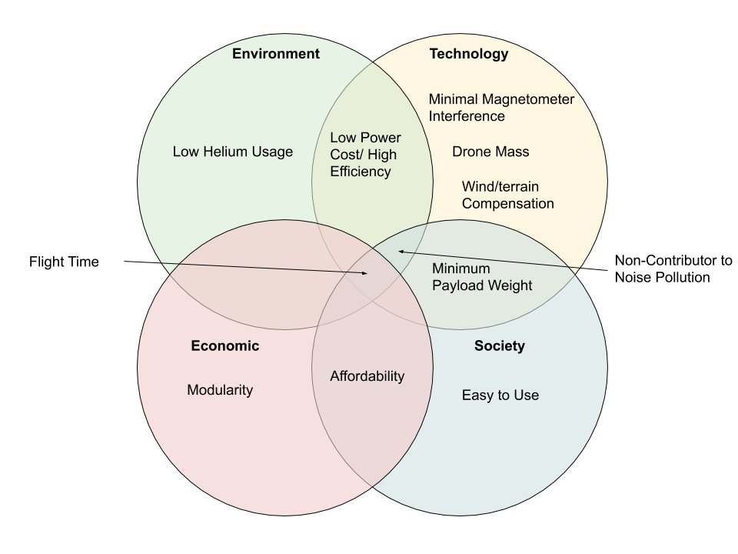

* Technology related considerations are the most applicable to our project. This is because our project is tailored more towards researchers than the general public, so accurate data collection is more important than other factors. When it comes to the other considerations, the drone is for a niche group, so will not be mass produced, reducing the applicability of environmental and societal considerations.
* Long flight time and low magnetometer interference are the most important criteria. These factors will allow for our drone to do more accurate data collection of previous drones in less flights.

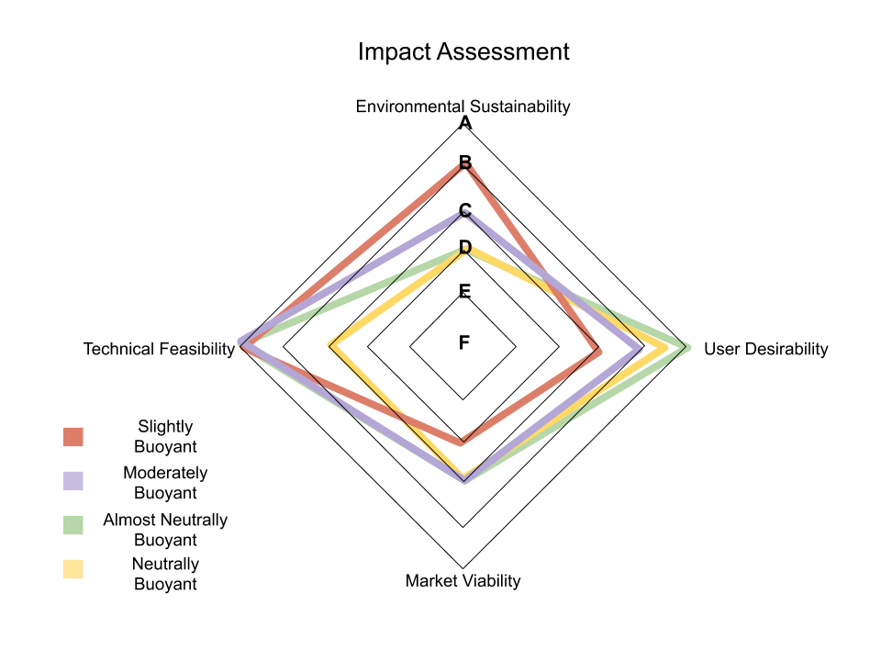

Slightly Buoyant:

* Environmental Sustainability B
* User Desirability D
* Market Viability E
* Technical Feasibility A

This design focuses on efficient battery usage and low cost; however, the reliance of battery stunts flight time and the heavy reliance on motors also hurts magnetometer accuracy. These two effects ruin the main desirable features of a buoyant drone. Although this design uses the least helium of all designs, giving it the highest environmental score, its use of 3D printed parts still keeps it from getting a great score. This kind of drone, although easier to create, would not have much, if any, appeal over a standard drone, reducing its market viability.

Moderately Buoyant:

* Environmental Sustainability C
* User Desirability B
* Market Viability C
* Technical Feasibility A

This design allows for enough buoyancy to obtain longer flight times, as well as reduce magnetometer interference, which gives it a higher desirability than the slightly buoyant design. It also does not yet have a massively larger surface area, allowing for better movement throughout the terrain than more buoyant designs. Its moderate use of helium gives it an environmental score worse than the slightly buoyant model.

Almost Neutrally Buoyant:

* Environmental Sustainability C
* User Desirability A
* Market Viability C
* Technical Feasibility A

This design seeks to strike the perfect balance of desirability and feasibility. By making the drone just under neutrally buoyant, the drone gains almost the full benefits of long flight time and low magnetometer interference while still maintaining its good terrain tracking abilities from its natural downward movement. This gives it the highest desirability score. The almost neutrally buoyant design also slightly improves its stability against wind over the fully buoyant drone. Its high helium usage however does hurt its environmental score.

Neutrally Buoyant:

* Environmental Sustainability D
* User Desirability A ~ B
* Market Viability C
* Technical Feasibility C

The design seeks to gain maximum benefit from the advantages buoyancy provides. However, extra effort is now needed to push the drone downward and thus it becomes harder to control. With its large surface area, compensating for wind is its most difficult challenge. Although this design would give huge increases to flight time and little interference with the magnetometer, giving it a very high desirability score, this model is held back only by its control difficulties. It scored low on feasibility due to its wind compensation and worse terrain tracking due to poor downward movement. It also uses the largest amount of helium of any design giving it the lowest environmental score.

# Parts List and Budget

## Parts List

*\*Shop link are included on full spreadsheet\**

| Name | Description | Designator | Quantity | Manufacturer | Supplier | Total Weight/Volume | Total Price [$] |
| --- | --- | --- | --- | --- | --- | --- | --- |
| Raspberry Pi Zero | Microcontroller | M1 | 1 | Raspberry Pi | Raspberry Pi | 8.5g | $5.00 |
| MPL115A2 | Pressure/Temperature Sensor | S1 | 2 | Freescale Semiconductor | Adafruit | 1.22g | $15.90 |
| MTK3339 | GPS Module | S2 | 1 | Mediatek | Adafruit | 4g | $29.95 |
| D1306-CCW | Motor | MOT | 4 | Turnigy | Hobbyking | 46g | $31.66 |
| X-Rotor 250 | ESC/ Motor Telemetry | ESC | 1 | X-Rotor | Hobbyking | 13g | $38.92 |
| Master Airscrew 9 x 4.5 Multi Rotor Propeller Set White | Propeller | PROP | 2 | Master Airscrew | Hobbyking | 19.4g | $11.78 |
| Carbon Fiber Filament - 1.75mm | 3D Printer Filament | FIL | 1 | NylonX | Matterhackers | TBD | $58.00 |
| 850mAh 4S 60C Lipo Pack | Motor battery 850mAh | BAT1 | 1 | Turnigy | Hobbyking | 106g | $12.64 |
| LIPO785060 2500mAh 3.7V | Microcontroller and peripheral battery 2500mAh | BAT2 | 1 | PKCELL Battery | Adafruit | 34g | $12.50 |
| OSH Park PCB | PCB printing | PCB | 1 | OSH Park | OSH Park | TBD | TBD |
| 8245-H Hwoyee Weather Balloon | Helium Lift Bag | LFTB | 1 | Hwoyee | Scientific Sales | 1600g | $155 |
| CS238MG Metal Gear Servo | 4.6kg / 0.14sec | SRVO | 3 | Corona | Hobbyking | 66g | $22.59 |
| 60ft3 Al He Cylinder W/ CGA580 Valve | Helium | He | 1 | Varies | Amazon | -1.02kg/m3 | $150 |
| AFHDS 2A system | Turnigy 9X 9Ch Mode 2 Transmitter w/ Module & iA8 Receiver and remote controller | RMT | 1 | Turnigy | Hobbyking | 10g for receiver | $59.49 |

## Budget

| EagleCAD library |
| --- |
| FALSE |

# Timeline and Major Milestones

## Flowchart

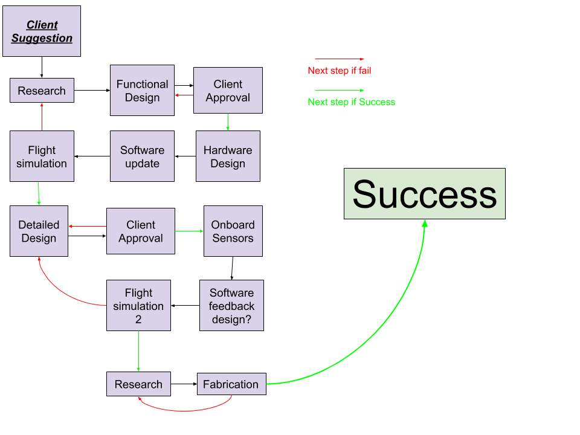

This flowchart offers a basic high level outline of the steps we need to take in order for this project to be considered successful. This chart highlights larger phases in the process of completing the project and does not include most of the smaller details nor do all the tasks have to be completed in exactly this order. This is merely for reference.

## 

## General Timeline

End of fall 2020: Completed project proposal/team charter

The general framework for the project, its goals, and team functionality will be completed.

Mid January: Functional design completion

The functional design will be the general approach of the project. It will include a general physical shape and a high level control system block diagram.

Two weeks before end of winter: Systems design and programming completed

The control system design including its implementation in the software will be completed.

End of winter 2021: Completed simulation and physical design - full scale. Parts ordered.

The simulation that is developed for the drones will be completed and the full scale drone design will be tested for its response. This will serve as the testing platform for the full scale design.

Start of spring 2021: Small scale design complete/begin manufacturing

The small scale design will be simulated as well, but this will also be tested as a proof of concept. The manufacturing phase starts early in the quarter to ensure there is adequate time for physical testing.

Mid-spring 2021: Small scale design built and testing starts at 2300 Delaware St.

Professor Mircea offered lab space at 2300 Delaware St. for us to test a small scale version of the drone. We will test the drone’s response to wind and terrain, as well as the drone’s flight time, magnetometer interference, and noise level.

2 weeks before the end of spring: Testing completed

The testing is completed two weeks ahead of the end of the quarter to provide time to analyze the results and compile the final report and documentation.

End of spring 2021: Completed drone assembly and working prototype

Final small scale drone is ready to be presented to USGS. This includes minor changes to physical appearance to be presentable.

End of spring 2021: Completed project report and documentation

A detailed project report will be completed that includes parts and specifications for both the small scale and full scale drone. The physical results as well as the simulation results will be included. Software documentation will also be provided that contains the description of the onboard software as well as simulation software.

## 

## Milestones

| **Major Milestones** | **Dependencies** | **Resources** | **Deadline** |
| --- | --- | --- | --- |
| 1. Working simulation of full scale drone | 0 | 1x | End of Winter |
| 2. Full CAD model of drone | 1 | 1x | End of Winter |
| 3. Fabrication and testing of small scale drone | 1,2,4,5,6,7 | 2x | End of Spring |
| 4. Full PCB design | 0 | 1x | End of Winter |
| 5. Embedded programming finished | 1 | 1x | End of Spring |
| 6. Control systems programming finished | 0 | 1x | End of Winter |
| 7. Power management completed | 4 | 1x | End of Spring |

# 

# Annotated Bibliography

[1]

J. Koiwanit, “Analysis of environmental impacts of drone delivery on an online shopping system,” *Advances in Climate Change Research*, vol. 9, no. 3, pp. 201–207, Sep. 2018, doi: [10.1016/j.accre.2018.09.001](https://doi.org/10.1016/j.accre.2018.09.001).

This study presents a life cycle assessment study on drone delivery in Thailand using CML2001, the life cycle impact assessment (LCIA) method, to convert life cycle inventory data into environmental impacts. The observed results show that an online shopping system using drone delivery is one of the most environmentally friendly transportation options throughout a wide range of scenarios. However, the production of the parts contributed to significant impacts on environmental issues while the drone operation showed the least impact on all impact categories.

[2]

Y. Zhang and D. Liu, “Influences of initial launch conditions on flight performance of high altitude balloon ascending process,” *Advances in Space Research*, vol. 56, no. 4, pp. 605–618, Aug. 2015, doi: [10.1016/j.asr.2015.04.031](https://doi.org/10.1016/j.asr.2015.04.031).

In this paper, a novel dynamic model was established to describe thermodynamic and kinetic characteristics of the balloon which consists of atmospheric, thermal, and dynamic submodels. Based on the model, ascending processes of a high altitude balloon under different initial launch conditions were simulated. The initial launch conditions were classified into three types: inflating quantity, launch time, and launch position. The ascending velocity and the differential pressure were defined and used as evaluation parameters of flight performance. Results showed that the inflating quantity is the most effective factor for the ascending process, and the upper and lower limits were also proposed separately from safety and performance perspectives.

[3]

Y. Bestaoui Sebbane *et al.*, *Lighter than Air Robots*, vol. 58. Dordrecht: Springer Netherlands, 2012.

This textbook examines Lighter Than Air Robot, unmanned lighter than air vehicles with sufficient autonomy. It teaches how lighter than air systems are particularly appealing since the energy required to keep them airborne is small. The lift of the lighter than air robot is mainly aerostatic, as opposed to aerodynamics as in airplanes and helicopters. Consequently, lighter than air robots spend most energy moving and compensating for wind disturbances, rather than trying to keep themselves on air.

[4]

M. Rogulski, “The use of low-cost measuring devices for testing air quality in hard-to-reach locations,” *E3S Web Conf.*, vol. 44, p. 00151, 2018, doi: [10.1051/e3sconf/20184400151](https://doi.org/10.1051/e3sconf/20184400151).

This article examines the air quality assessment traditionally carried out by ground monitoring, with the development of technology and the creation of small, low-cost sensors. The results show it became possible to effectively study lower tropospheric layers by using light aircraft and balloons. The article presents the use of designed small, portable devices using low-cost dust sensors to research air pollutants using a hot air balloon. The results of measurements of PM1 concentration using tethered balloon flights and during a free flight they found where a balloon with a measuring device can be an effective transport medium for analyzing the vertical spread of particulate matter and other gases in the atmosphere, where that higher altitude tests can be conducted during a free flight, while for lower altitudes a better solution is to use a tethered balloon.

[5]

M. Sato, M. Nirei, Y. Yamanaka, T. Suzuki, Y. Bu, and T. Mizuno, “Increasing the efficiency of a drone motor by arranging magnetic sheets to windings,” *Energy Reports*, vol. 6, pp. 439–446, Feb. 2020, doi: [10.1016/j.egyr.2019.11.100](https://doi.org/10.1016/j.egyr.2019.11.100).

This study conducted an experiment on drone motors, using magnetism to improve the efficiency of the motors by surrounding a specific part of the motor with sheets. These sheets provide a magnetic field that lessens the magnetic flux leakage of the motor itself, which reduces heat dissipation and power loss due to it. The findings show how the magnetic field can reduce the electrical resistance and improve the thermal conductivity of the materials that make up some parts of the inside of the motor. This study can help us with our project by providing us with a method of understanding the magnetic fields and the possible interference of the carriable magnetometer of our drone.

[6]

S. Yadav, “THRUST EFFICIENCY OF DRONES (QUADCOPTER) WITH DIFFERENT PROPELLERS AND THERE PAYLOAD CAPACITY,” vol. 4, p. 6, 2017.

Drones are studied in this research with the purpose of mechanically improving payload capacity and power efficiency of drones by using different thrust levels in different rotors of tri-copters and quad-copters individually. We can see different propellers placed in different configurations on drones can improve the total thrust and lift provided, which will allow the drone to have an increased payload capacity with an optimized propellor setup. The placement and usage of these different propellers will also provide different power consumption values, which can help us with the power load of the propellers while also taking the drone’s controls into consideration.

[7]

R. W. Beard and T. W. McLain, *Small unmanned aircraft: theory and practice*. Princeton, N.J: Princeton University Press, 2012.

This book prepares the reader to do research in the rapidly developing field of autonomous navigation, guidance, and control of unmanned air vehicles. The focus is on the design of the software algorithms required for autonomous and semiautonomous flight. It goes over a wide range of the necessary information researchers must be familiar with to work in this area, including coordinate transformations, aerodynamics, autopilot design, state estimation, path planning, and computer vision. The aim of this book is to cover these essential topics, focusing in particular on their application to small and miniature air vehicles, which we denote by the acronym MAV.

[8]

A. Prystai, V. Korepanov, F. Dudkin, and B. Ladanivskyy, “Vector Magnetometer Application with Moving Carriers,” vol. 207, no. 12, p. 7, 2016.

This article discusses interference in fluxgate magnetometers (FGM) attached to a drone. During movement of FGM fixed to a drone practically permanent attitude changes in the Earth’s magnetic field arises with corresponding changes of its projection at FGM axes. Also the electromagnetic interference from the drone motor and uncontrolled oscillations of drone and suspension are the factors which limit the magnetometer sensitivity level. Aroused because of this, signals significantly exceed the expected signals from a studied object and so should be removed by proper interference filtration and use of stabilized towed construction, as well as at data processing. The article discusses how its model tries to solve these problems.

[9]

Sigalos, Athanasios & Papoutsidakis, Michail & Chatzopoulos, Abraham & Piromalis, Dimitrios. (2019). DESIGN OF A FLIGHT CONTROLLER AND PERIPHERALS FOR A QUADCOPTER. *International Journal of Engineering Applied Sciences and Technology*. 4. 463-470. 10.33564/IJEAST.2019.v04i05.067.

This research paper provides a guide on how to design a PCB board for a quadcopter. It explains the history of quadcopters and why the PCB board is designed in such a way. The paper also gives an extensive description of the microcontroller, sensors, and other peripherals used in the construction of the drone. The operation of the quadcopter is later explained for how to program and control the quadcopter. The paper shows the layout of the PCB design for every sensor and peripheral that needs to be attached to the board.

[10]

H. L. Edge, A. Brown, and J. Collins, “Pressurized Structures–Based Unmanned Aerial Vehicle Research,” *Journal of Intelligent & Robotic Systems*, vol. 65, no. 1-4, pp. 603–620, 2011.

This article looks at the applications of UAVs that include some kind of buoyant component. The study examines areas where buoyancy can be implemented in the structure as well as potential problems faced with these types of UAVs. The research here is considering military vehicles and was published in 2011, so not everything applies. For example, 3D printing materials have made a large improvement since this article was published but are still not feasible for a large aircraft, however, 3D printed materials can be used on something smaller like our drone. This research still provides a good basis of where to begin.

[11]

J. M. G. Glen, A. E. Egger, C. Ippolito, and N. D. Athens, “Correlation of Geothermal Springs with Sub-Surface Fault Terminations Revealed by High-Resolution, UAV-acquired Magnetic Data,” p. 8.

This report is by Jonathan Glen, the representative of USGS who we will be in contact with our team throughout the duration of the project. This article directly relates to the work that he will want to do with our drone, collecting magnetic data in order to find the location of geologic activities. We will reference this article in order to see how previous drones were used for this task.